**WEEKLY-TAST-KUBERNETES**

**Test Case 1: Successful Deployment**

Scenario: Execute the deployment script or process.

Expected Result: All microservices (frontend, backend, database) are successfully deployed to

the Kubernetes cluster without any errors. Verify that the pods are running and services are

accessible.

Executed the deployment script.

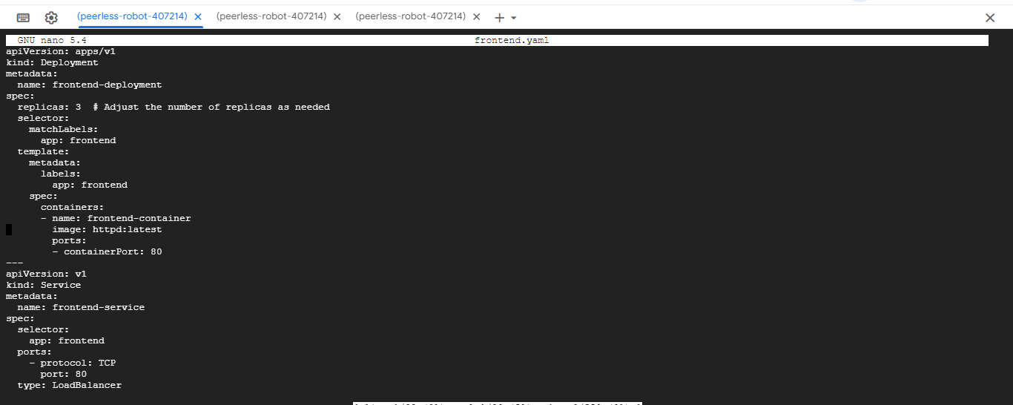

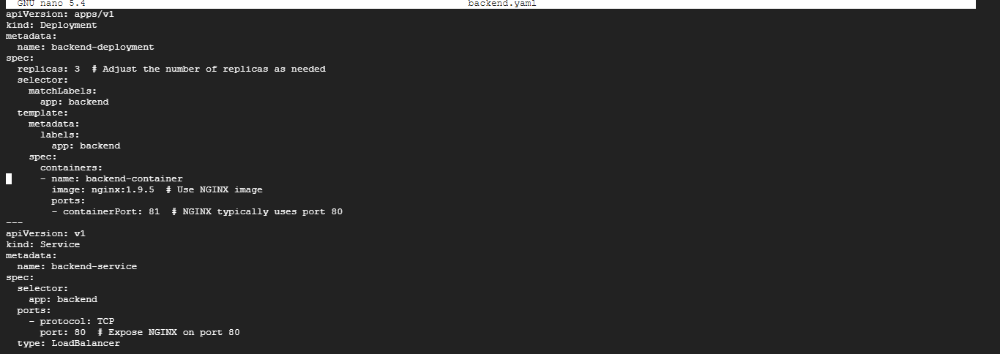

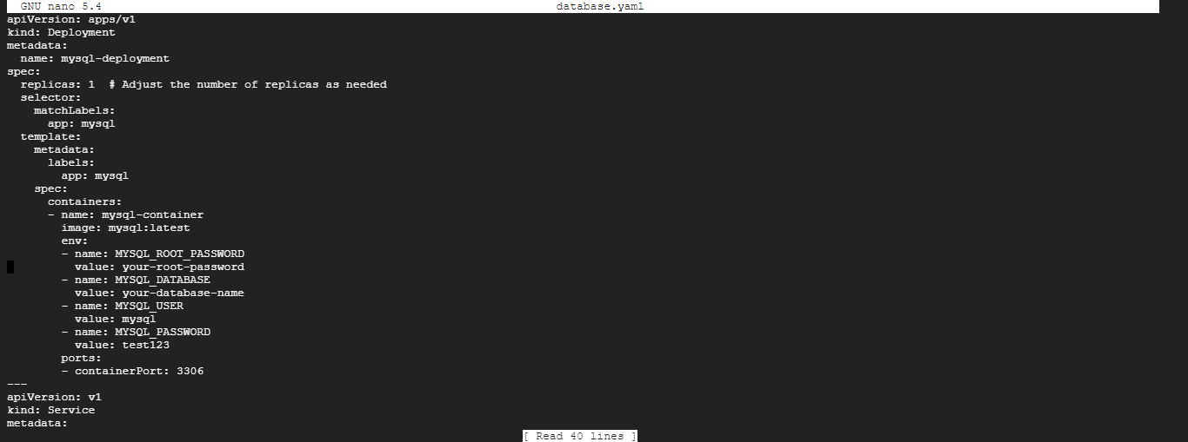

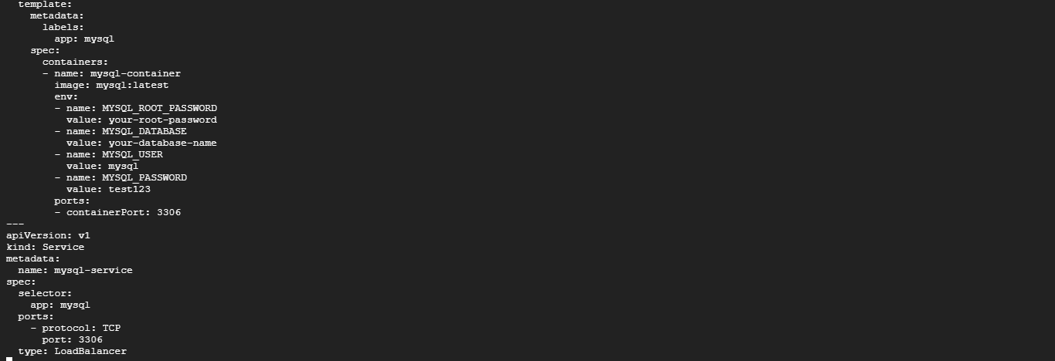

Expected Result: All micro services (frontend, backend, database) are successfully deployed to

the Kubernetes cluster without any errors.



Verify that the pods are running

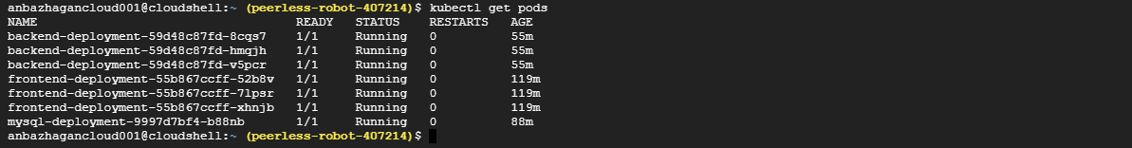

services are accessible through external IP

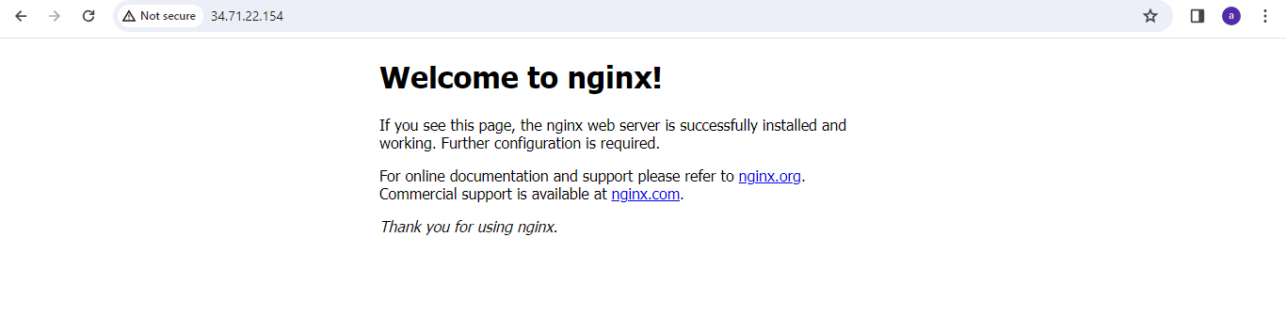

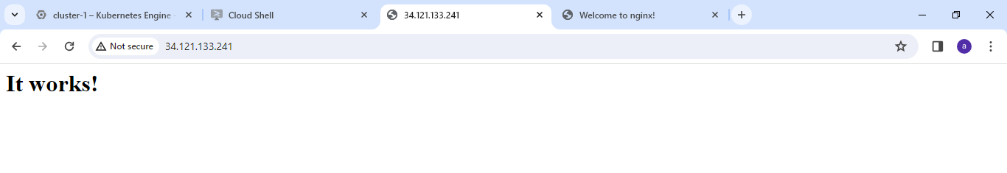

**Test Case 2: Rolling Deployment Validation**

Scenario: Initiate a new release using the deployment script or process.

Expected Result: The backend microservice should undergo a rolling deployment, updating the

replicas gradually without causing downtime. Verify that the application remains accessible and

responsive throughout the deployment.

Change the backend-deployment. yaml file script backend micro service should undergo a rolling deployment, updating the replicas gradually without causing downtime.

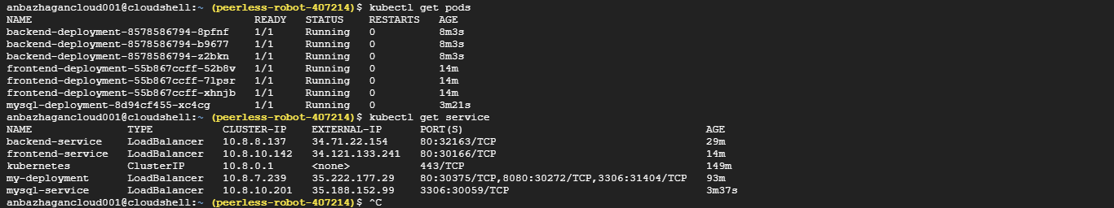

**Test Case 3: Ingress Configuration**

write the ingress configuration script for the frontend micro services

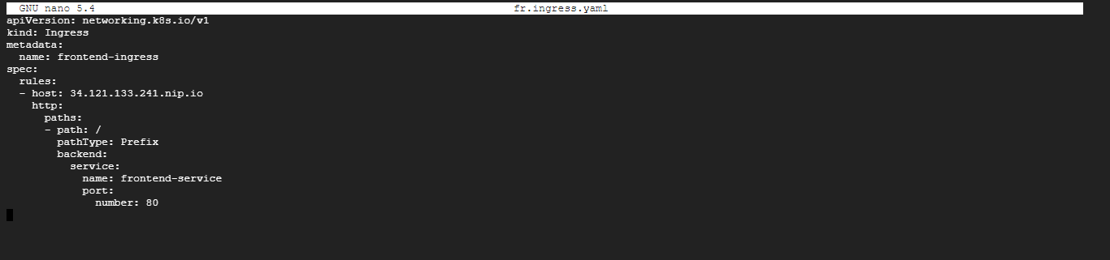

After run the kubectl apply –f frontend-ingress.yaml file command . 34.121.133.241.nip.io using this URL access the front server .

